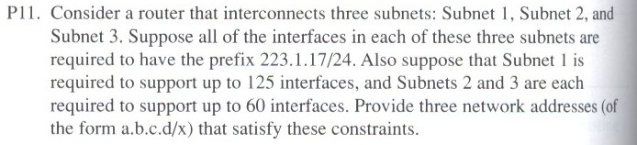

Subnet 1: 223.1.17.0/25

Subnet 2: 223.1.17.128/26

Subnet 3: 223.1.17.192/26

1. Suppose we are using Distance Vector Routing protocol.

4

1

40

(a)

100

1

40

(b)

9999

1

40

(c)

1. Please give the distance vector of A, B, and C as follows for scenario (a):

A to B: 100 A to C: 1

B to A: 100 B to C: 40

C to A: 1 C to B: 40

1. What happens if link cost of AB becomes 100, as shown in scenario (b)?

A to B: 9999 A to C: 1

B to A: 9999 B to C: 40

C to A: 1 C to B: 40

1. How many rounds it takes for the protocol to converge to the above actual minimum distance?
2. What happens if link cost of AB changes from 100 to 9999, as shown in scenario (c)?
3. What happens if link AB breaks, will the protocol be able to converge to some final minimum distance? If not, why?